**Data Programming in R -** Group Project Report

Kristine Arens, Cody Burger, Michelle Cutlip, Ben Huntington and Matthew Pelham

The Situation

Our team analyzed data from post-secondary institutions to answer the question: Which factors contribute to higher or lower student loan default rates? In addition to exploring the overall relationship between the cost of tuition on default rates, we sought to answer three sub-questions:

1. Did the program length influence the overall cost of attendance and what effect did the program length have on the overall default rates.
2. Did the type of university (public, private, proprietary) play a part in the default rates at institutions across America.
3. Were there any relationships between the geographic location of these institutions and the default rates.

Data from the Department of Education and National Center for Education Statistics and Integrated Post-Secondary Educational Data System were joined into a single data frame and analyzed using R. Prior to our research, the general hypothesis was that higher tuition rates would lead to higher default rates. Quite surprisingly, our research provided findings of the opposite.

The Data

Post-secondary loan default data was found on the Department of Education’s Federal Student Aid site which included number of students in default, number in repayment, the school’s default rate, rate type, ethnic affiliation of the school, and school location (this will further be referred to as “PEPs” data). The specific dataset used was set 300 which coveredofficial cohort default rates published for schools participating in the Title IV student financial assistance programs for fiscal years 2012, 2013 and 2014. The dataset was strengthened with data from the Integrated Postsecondary Education Data Statistics division of the National Center for Education Statistics (this will further be referred to as “IPEDS” data). This site hosted many datasets, and it was decided to only pull key items per school for years 2012 and 2013 including: geographic coordinates, attendance, cost, average grant money received per student, average loan amount received per student, percentage of students receiving loans. The data dictionaries for each dataset were also downloaded.

Use of the Data

The IES Policies are aligned with the U.S. Department of Education's Plan and Policy Development Guidance for Public Access, which was approved October 21, 2016. ED encourages researchers to maximize the data made available to the public.

Aligning the Data

The PEPs data was indexed by an OPEID which is the Department of Education’s identifier. The IPEDS data was indexed by UNIT_IT. An intermediary dataset which contained both the UNIT_ID and OPEID was located so that the two datasets could be merged.

Importing and combining the Data using R

The openlsx and dplyr libraries were loaded. The intermediary dataset was imported to a dataframe titled “codes”. The loan default data was read into the “peps300” dataframe, and the OPEID number was changed to an integer which removed the leading 0’s and the paste function was used to add 2 0’s to the end so that its format matched the “codes” dataset. The codes and default data were then merged into the codes_peps300 dataset. IPEDS data was pulled from 7 datasets on their site, and each set was loaded onto its own Excel sheet. Each sheet was read in as a dataframe, and then merged into the full dataframe called “full_df” using UNIT_ID as the linking source.

Preparing the data

The data required some cleaning before analysis could begin. The column names were changed to more meaningful terms. The data set was reduced to include only complete cases, and the school type was changed to a factor for analysis. We chose to analyze the average of 2012 and 2013 data for the amount of tuition and the default rates, and created a new variable, “Tuition_Binned”, which breaks the tuition into bins of $10,000 segments ranging from $0 - $50,000. In the PEPs dataset, the program length was simply a numeric value ranging from 3 to 12 which provided no insight to the user about the type of program. A new variable was generated for “Program Meaning” and classified each program as: Non-Degree (<1 yr), Non-Degree(1 yr), Non-Degree(2 yr), Associate's Degree, Bachelor's Degree, First Professional Degree, Master's Degree, Non-Degree(3 yr. +), and Two-Year Transfer.

The analysis

A summary table was generated to compare the cost of tuition against the length of program using the mean default rate as the measurement tool between the two variables. The summary table (*Appendix 1*) illustrates that shorter programs tend to have higher default rates. A rank-order function was applied to determine which program lengths consistently had the highest default rates. Non-degree (< 1 yr.), Non-Degree (2 yr.), and Associate’s Degree’s had the highest default rates. On the contrary, Bachelor’s degrees and First Professional Degrees were consistently among the programs among the lowest default rates. The table can be interpreted in ascending order—the lower the number the lower the default rate in rank order.

A density plot (*Appendix 2*) was generated to determine the strength of the relationship between the cost of tuition (binned) and the amount of the average default. The results were staggering as the relationship between the two variables has a strong inverse correlation—as tuition increased, the default rates decreased. The lower tuition bins were heavily skewed across the spectrum of the default rates and had more variation in default rates across the entire spectrum (zero percent, up to forty percent) while the higher tuition bins tend to have less variation among their default rates, and the overall default rates were much lower.

To capture a visual representation of the percentage of students in default among the programs, a scatter-plot was produced (*Appendix 3*). The scatterplot measures the mean default percentage on the cost of tuition on a continuous scale. The findings of the scatter plot were consistent with the previous finding that the lower the tuition, the higher the default rates. The two programs that appear most heavily in the scatter-plot are Bachelor’s Degree and Associate’s Degree. The scatter-plot heavily supports the density plot and summary table and indicates that Associate’s Degrees are among the programs with the highest default rates, while Bachelor’s Degrees are the lowest in default.

Through our analysis, it was evident that lower tuition amounts were indicative of higher default rates. However, it was unclear how strong that relationship was. As a way to measure this, a colored density-plot was deployed to analyze the factors of the total number of students in default on the cost of tuition. A higher frequency of default in any one area would appear on the density-plot as a darkened color (*Plot 1*). The colored density plot clearly shows that the highest number of students in default is clearly skewed towards lower tuition amounts.

*Plot 1: Frequency of Number in default vs. Cost of Tuition*

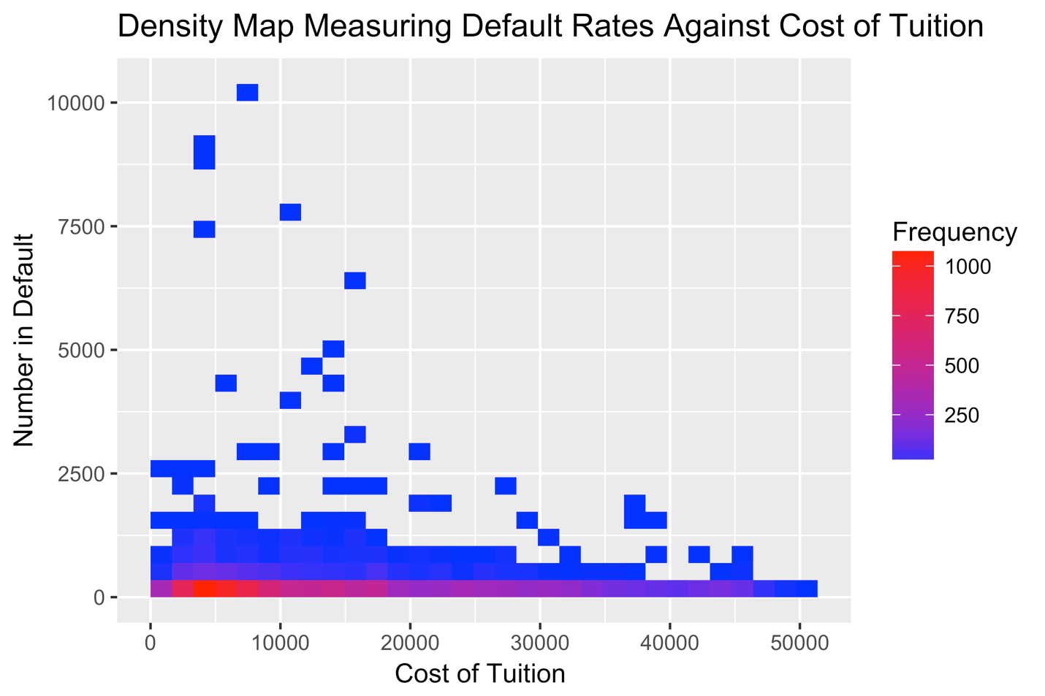

Summary of analysis

Although no statistical analysis was performed, we believe that there is a significant correlation between the cost of tuition and the chance of a student defaulting on those loans. From our analysis we know that those higher default rates are associated with three particular programs: Non-degree (< 1 yr.), Non-Degree (2 yr.), and Associate’s Degree’s. The curriculum offered by these degrees are often associated with lower paying jobs after graduation. There is most likely a correlation between the degree obtained, job qualifications post-graduation, salary, and ability to repay loans. Conversely, we know through our analysis that Bachelor’s Degree’s and First Professional Degrees have a lower default rate. One could conclude that this is related to higher paying jobs post-graduation and a better ability to repay those loans.

Obstacles faced

The group faced many challenges during the project, the first of which was locating data. We agreed on using school data for our project, but when our initial plans to use our group members’ employers’ data didn’t pan out we took to the internet. The default loan data was located, and it was well-organized and didn’t appear to need much cleaning. It didn’t include much demographic or school data, but it did include the OPEID. Further research ensued, and data was located on the IPEDS site regarding the schools which was indexed by UNIT_ID. Fortunately, a table was found that contained both the OPEID and UNIT_ID so that the two data sources could be merged. Our next challenge came when we discovered that the OPE_ID was not set up the same way on the datasets. In one there were leading 0’s, and in the other there were trailing 0’s. Once those were identified and transformed in R, the data could be merged.

When analyzation of the data began, it became apparent that there was not much variation in the default rates. We realized that the specific dataset we had imported was a subset of the full dataset and only included schools with a default rate of <15%. We then downloaded the full dataset and changed our import commands in R to pull in the full default dataset.

Communication proved to be another challenge. We initially set up a group on ICON with folders for documents, scripts, and datasets. We quickly found that we weren’t getting updated when additional comments were added to a discussion item, and it was difficult to manage script versions. We changed our communication to group email and began using GitHub to share files which solved this obstacle.

Conclusion of the analysis

Appendix

1. Summary Table: Program Meaning vs. Binned Tuition Price

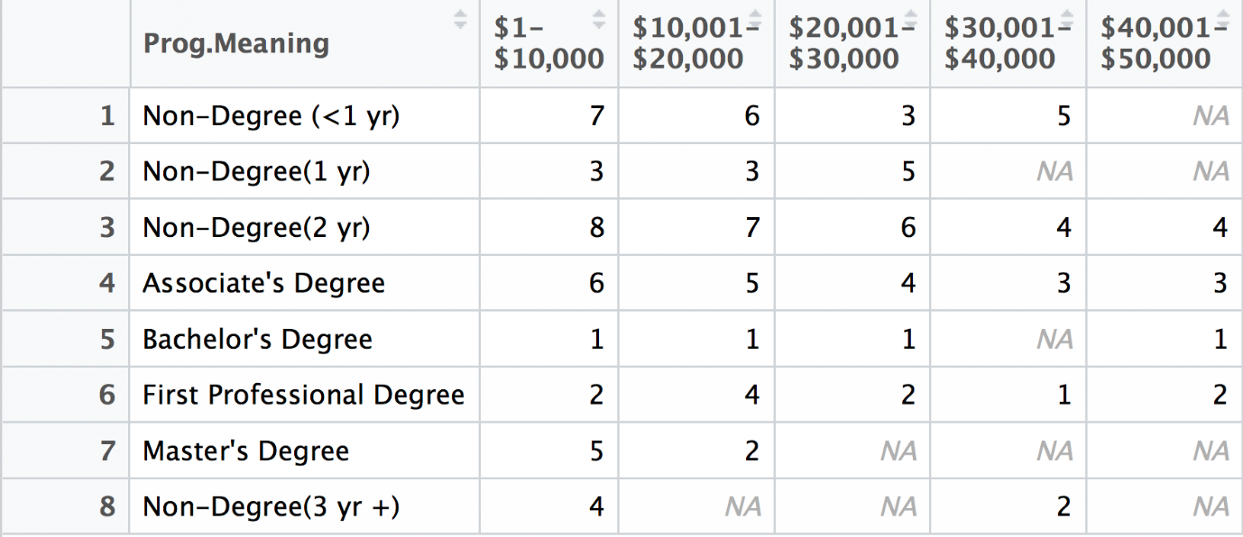

2) Density Plot: Default Rates Per Binned Tuition Price

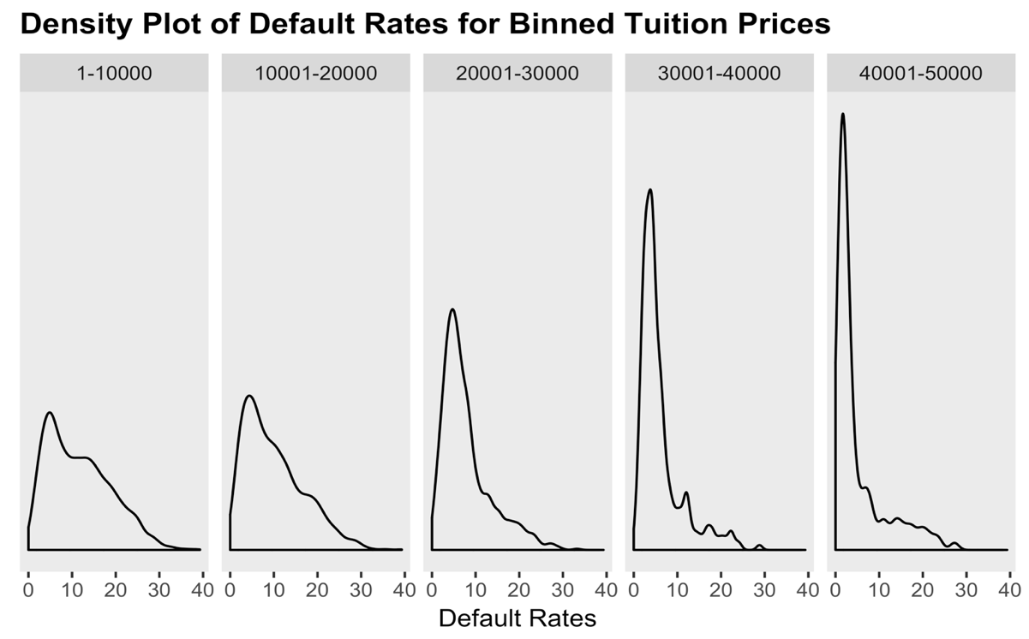

3) Scatterplot: Mean Default Rate on Cost of Tuition by Program Length

